Hello fellow fantasy football family!! (See what I did there dad??:)) I want to start by saying I was about ​the farthest thing from an English major, and my creativity is not the best, so don't expect a lot from my league note:) however, as I didn't want to pay the fine from opting out, (thanks Noelle) I decided to try a new approach. (As I knew I could never compete with the whit and cleverness of Noelle and Micah's league notes) And since mom did something totally different, and at the expense of appearing like an obsessed mom with her kid, I though why not? ​

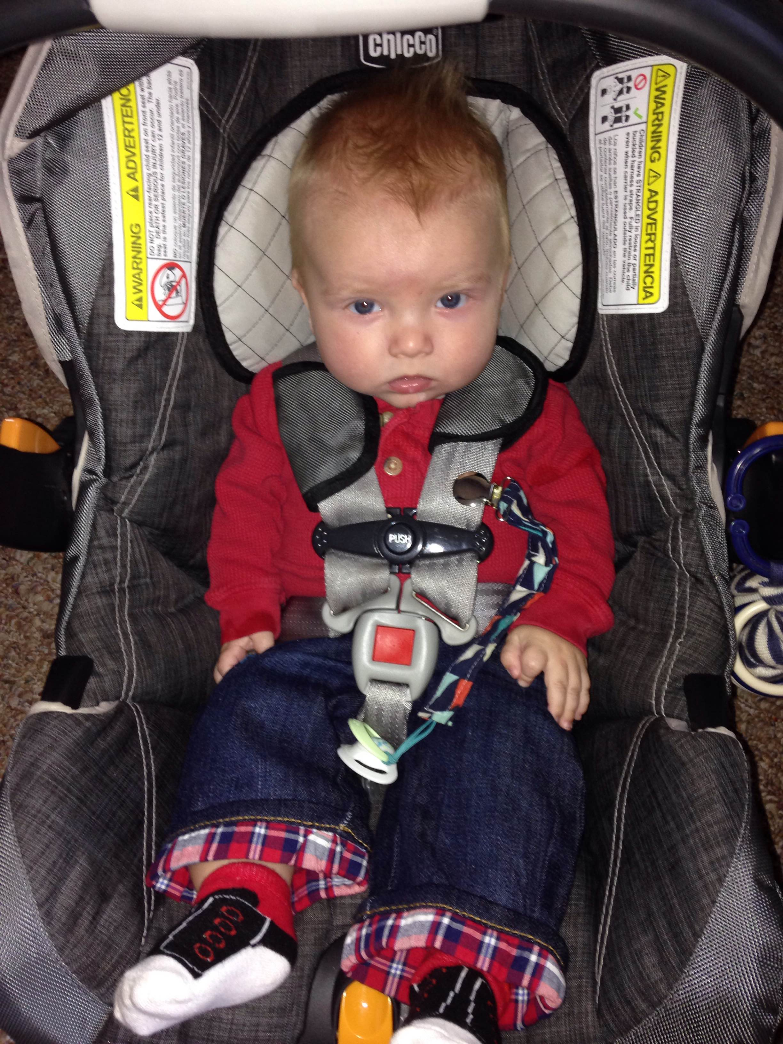

seriously mom, why can’t you just let me watch a game?

And oh my goodness, Uncle, I am so sorry to hear your main running back, Jamal Charles, possibly has an ACL tear?! This is unbelievable!! It’s just too much! How are you ever going to climb back up to the top?

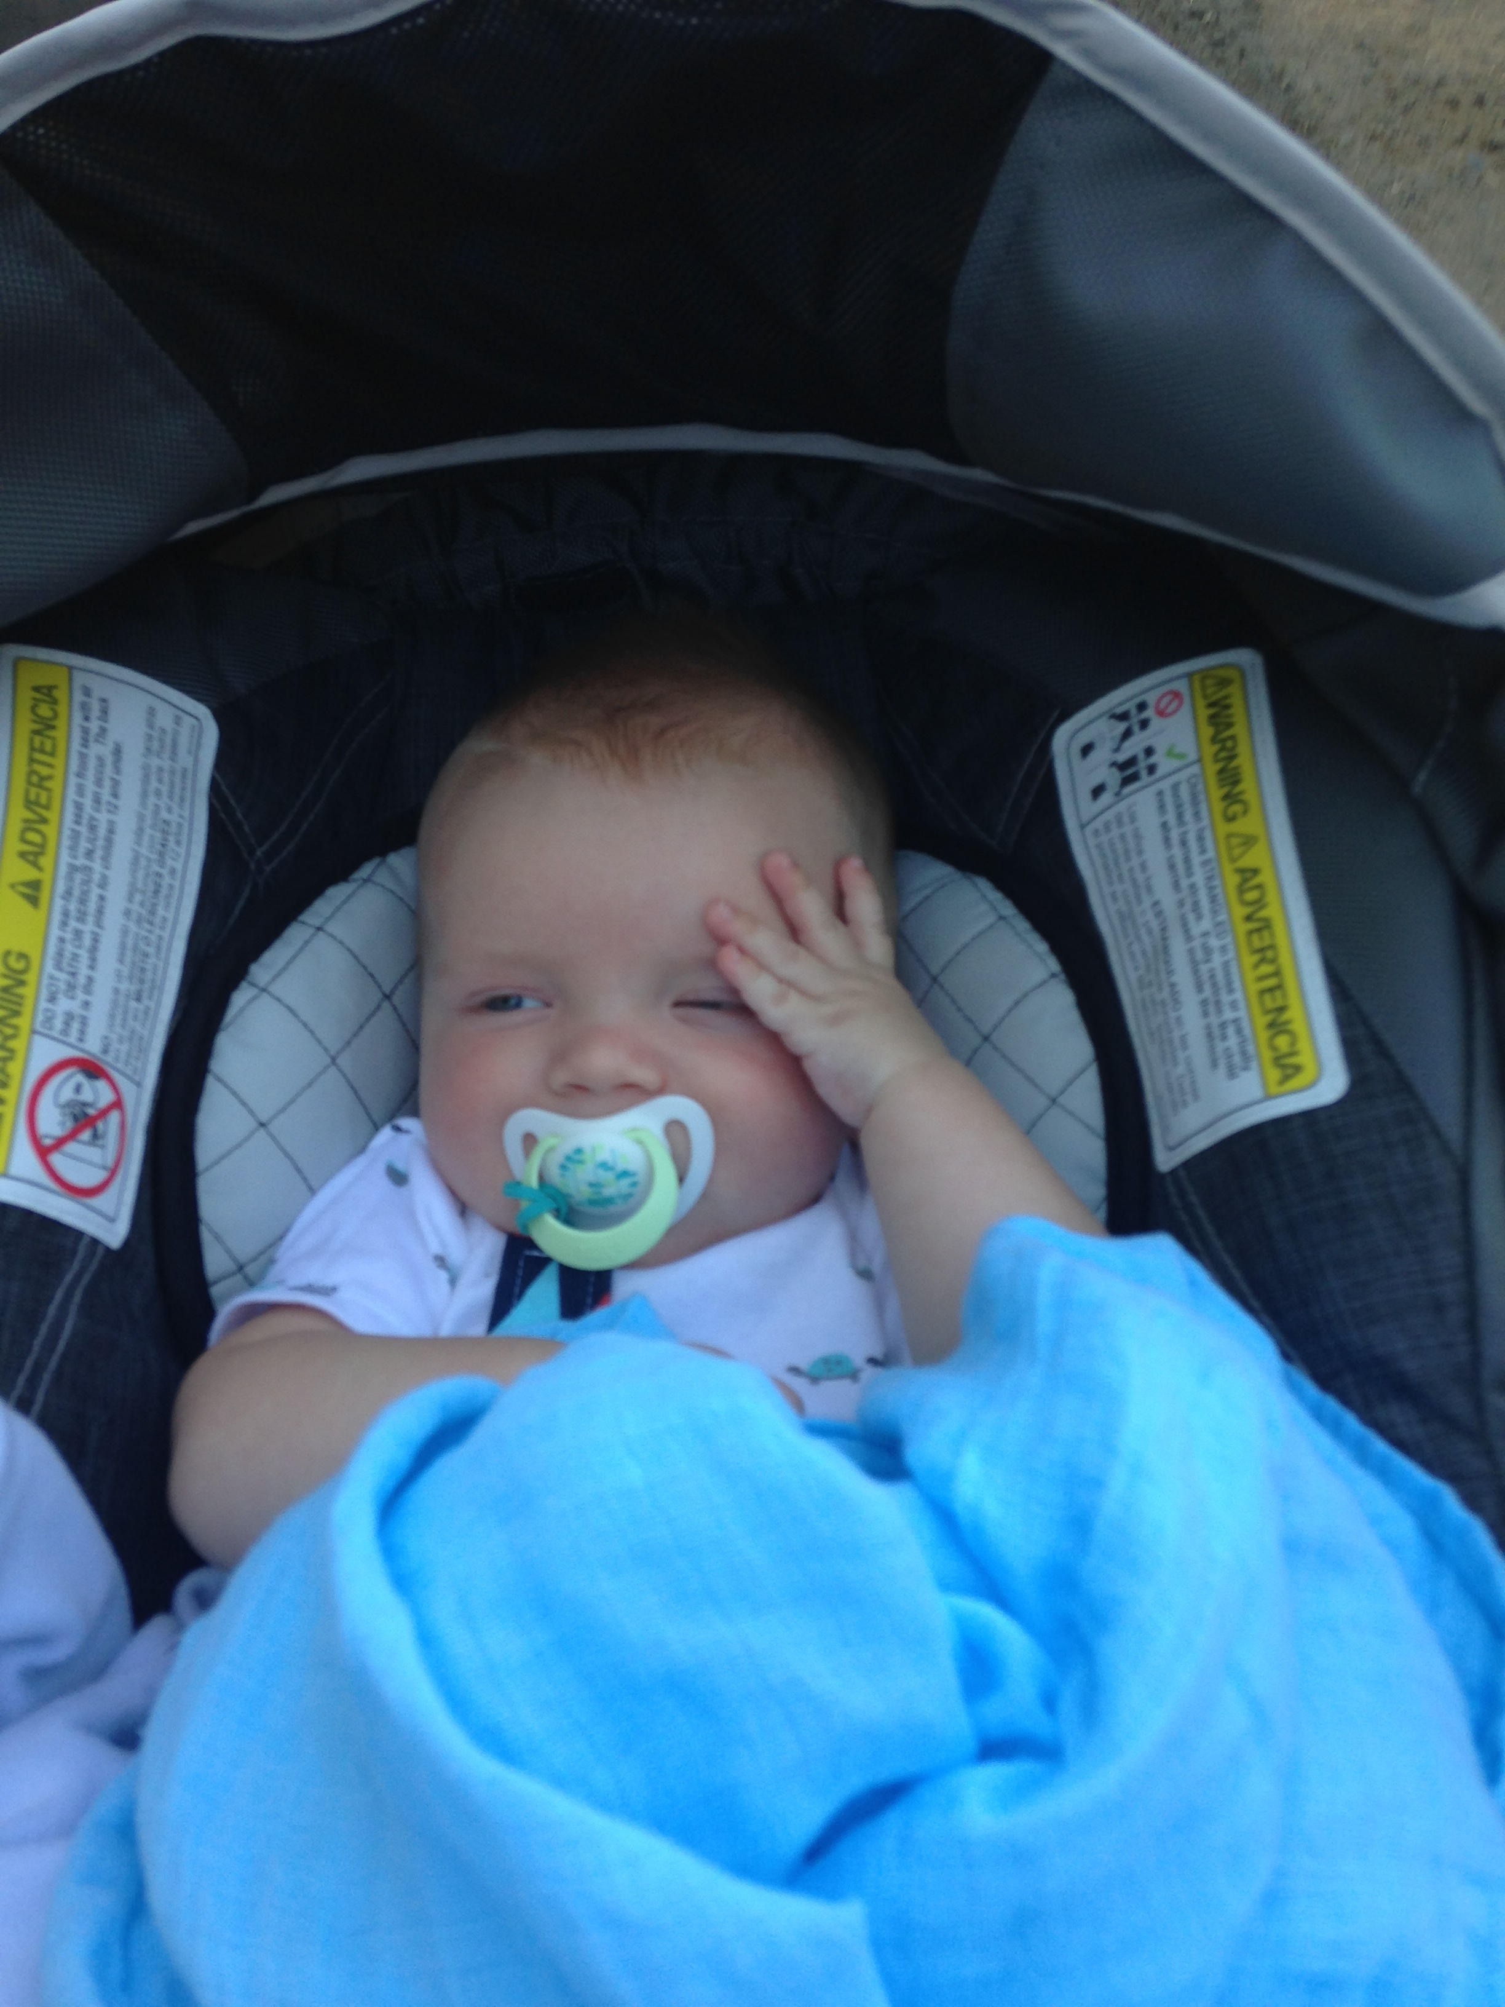

It’s just too much….too much…..

Auntie Ti-ti, I think with all the wedding planning and school, you have just given up on your team….i mean, your total score was almost as much as one of Auntie’s players….just sayin…..

“I am exhausted; I give up”

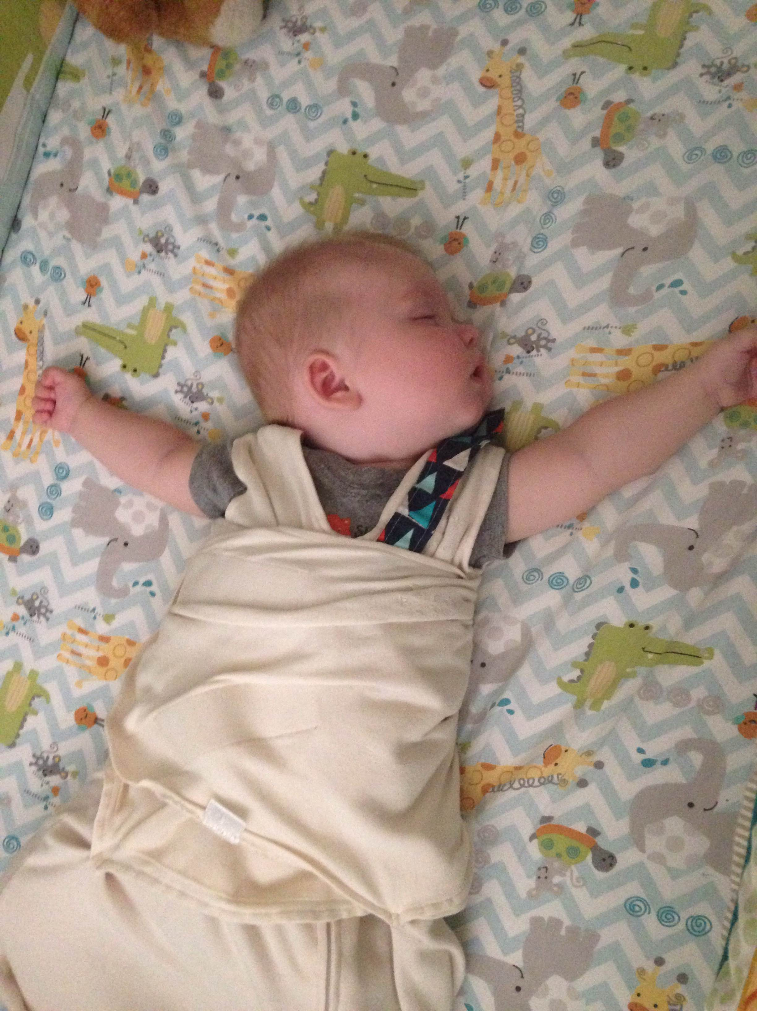

Speaking of Auntie, you were quite sneaky with your win this week….i mean you have only managed to win one game so far and then all of a sudden your defense decides to get you 22 points and Martin gets you almost 34 and Murray 18!! All in the same game!!! (against my mom no less!!!She was quite upset)

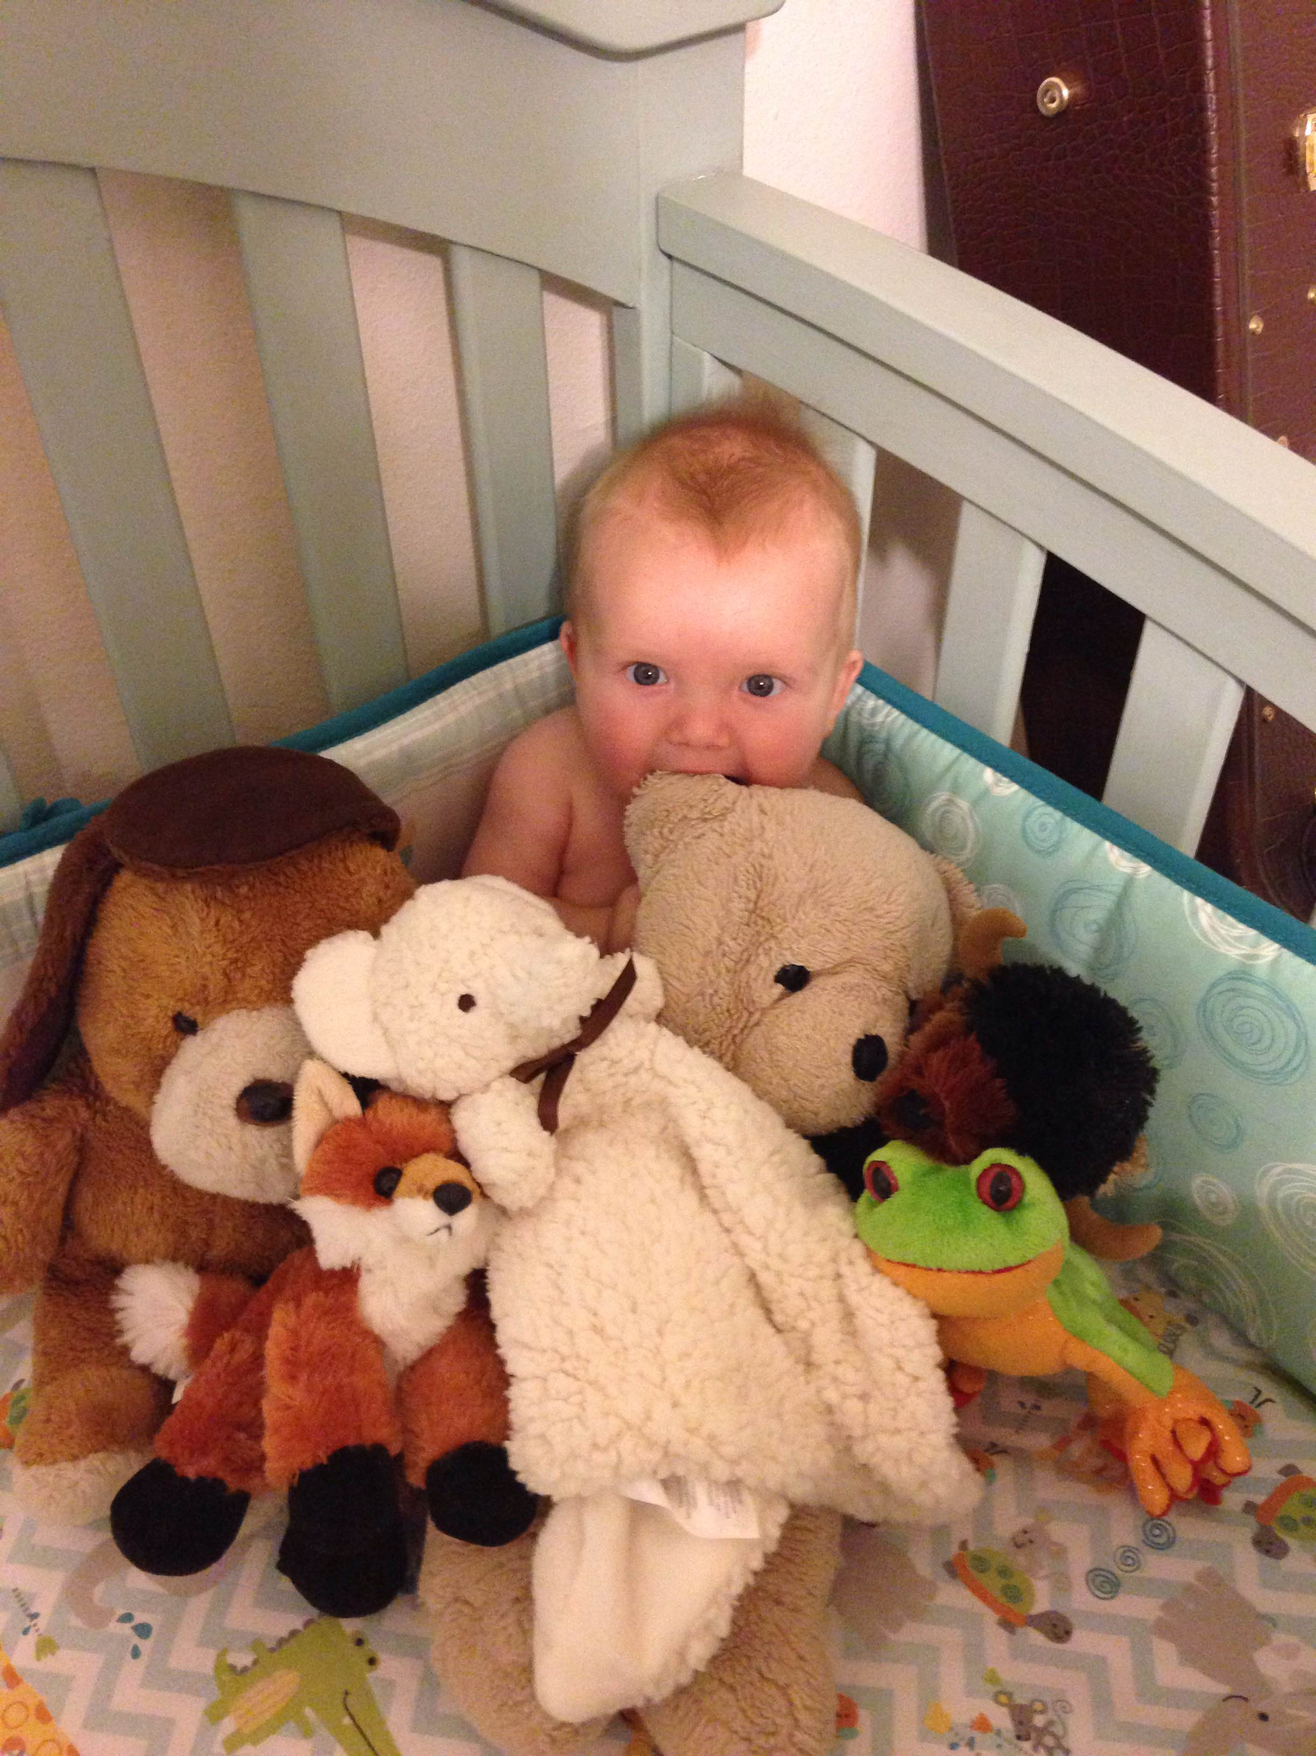

You sneaky girl!!!!

Papa, I think you need to sit down with your team and have a serious, heart to heart, talk. I mean, you were undefeated and on the way to win your second season in a row, and then it seemed as though you just lost focus.

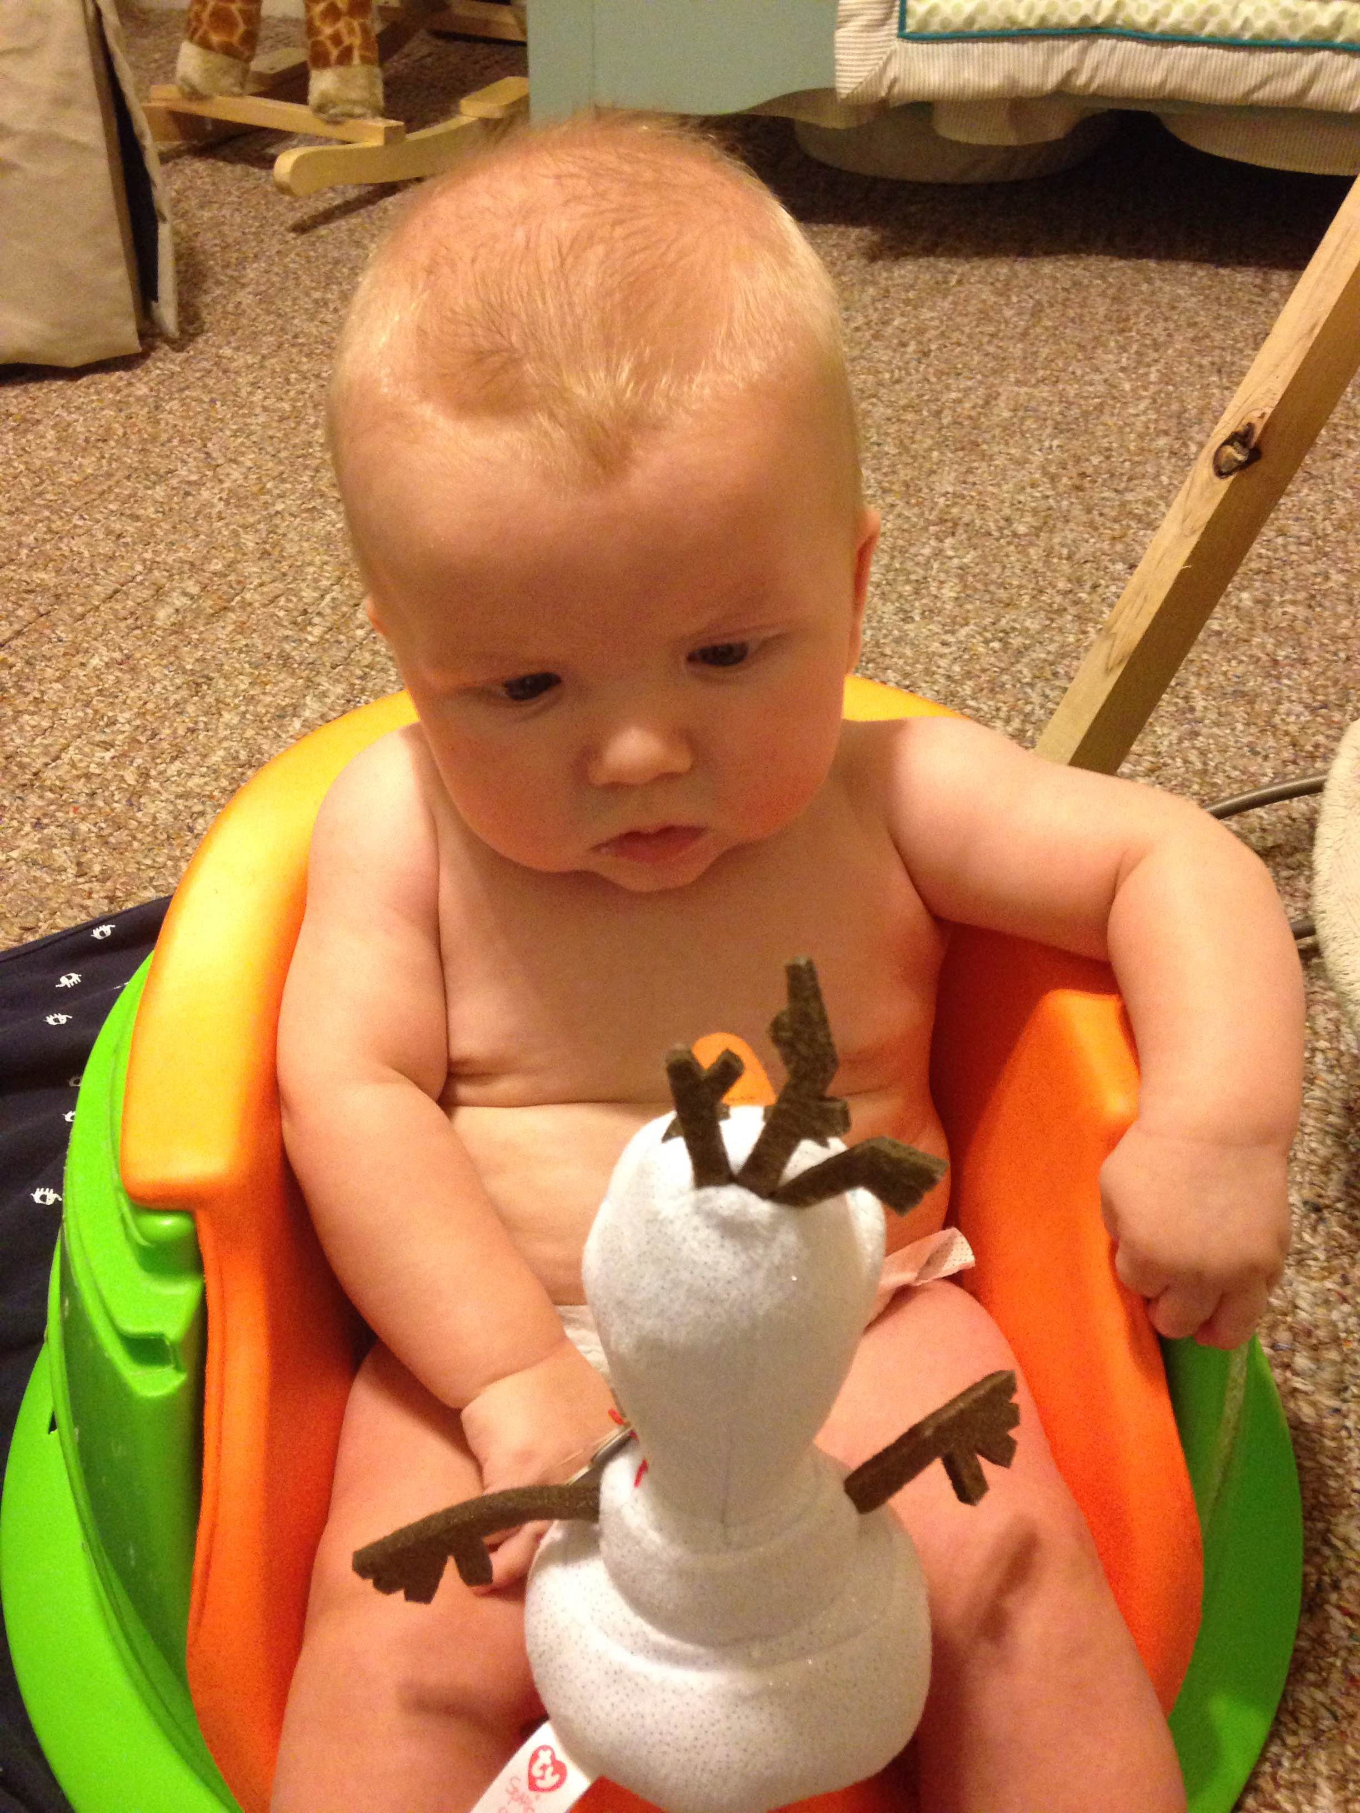

Ok guys, we need to step it up…..

Uncle Mi, I can only imagine the thoughts that went through your head this week……”What?! I actually scored above 90 points in a game!?! 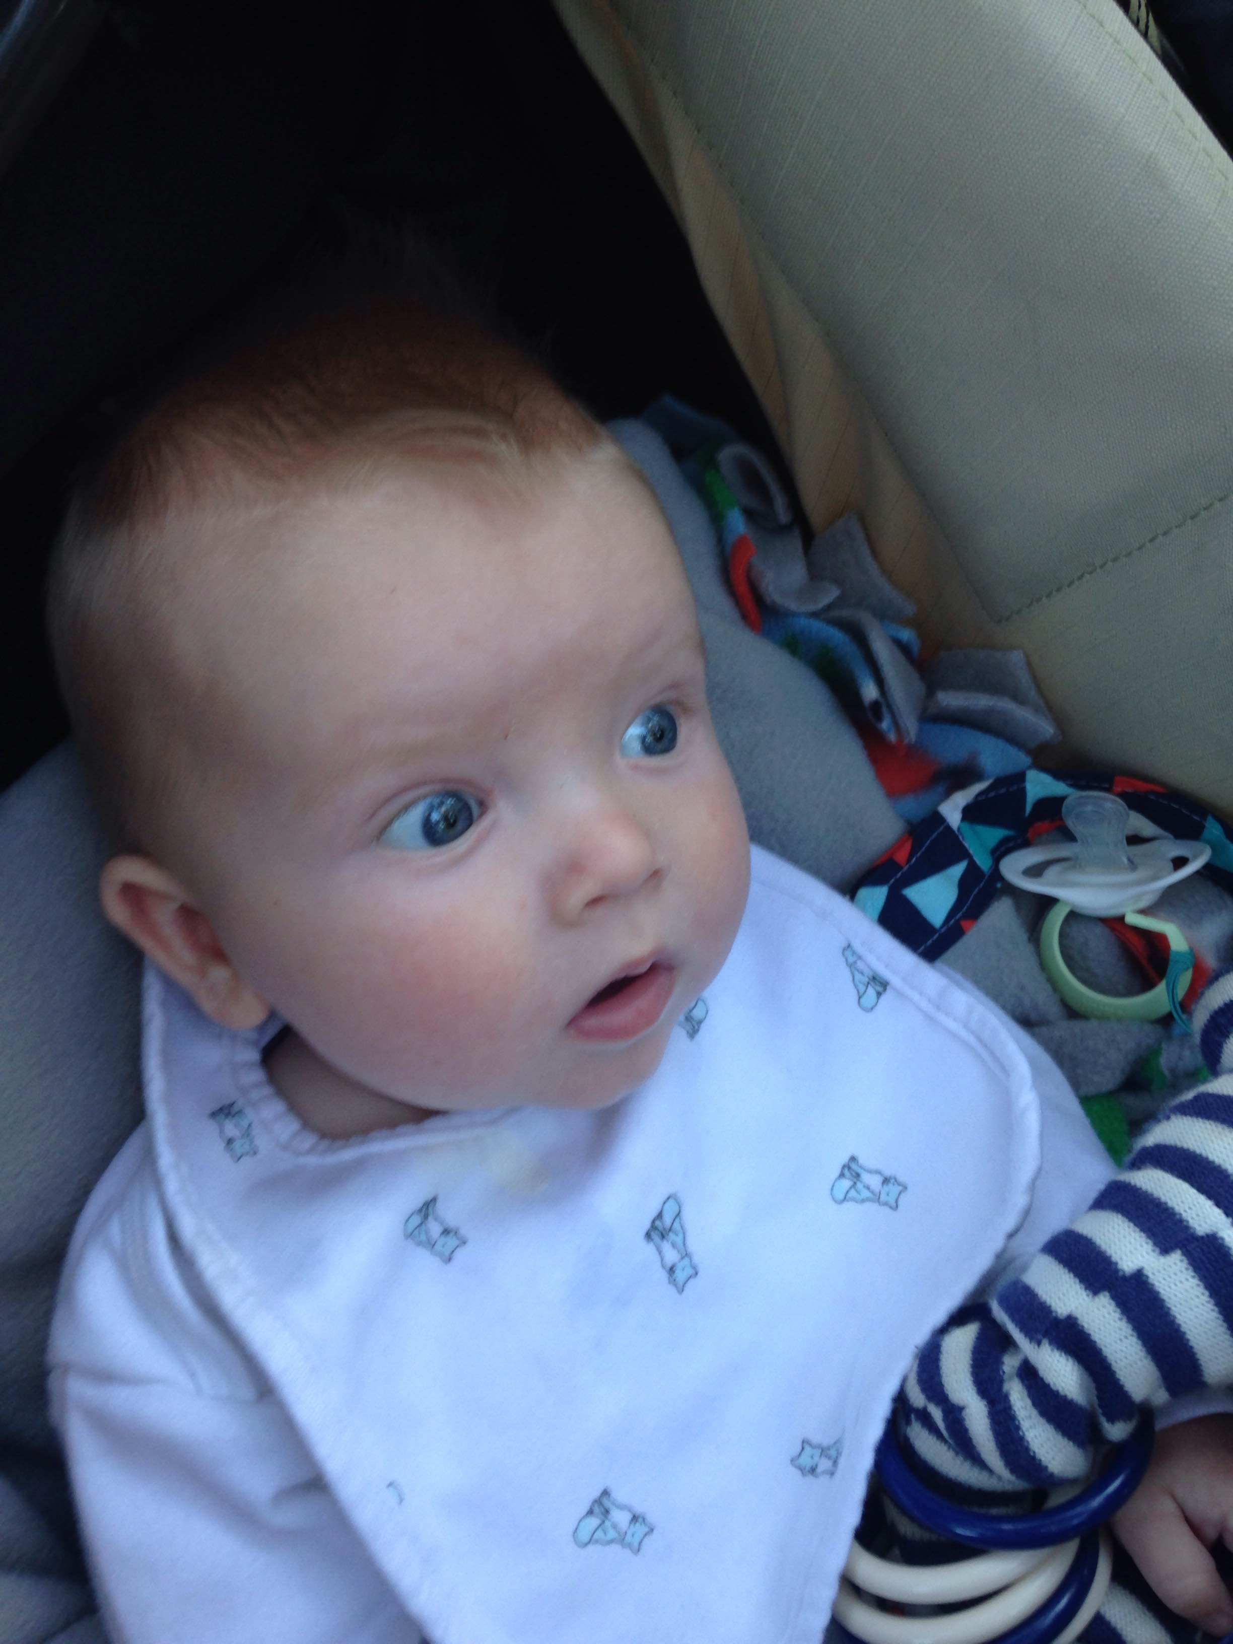

Is this real life???

Auntie Noelle, it’s a good thing you had so much cushion playing Papa this week since your tight end decided to get you zero points!!! And by the way, I love your new bedroom makeover….its adorbs…..

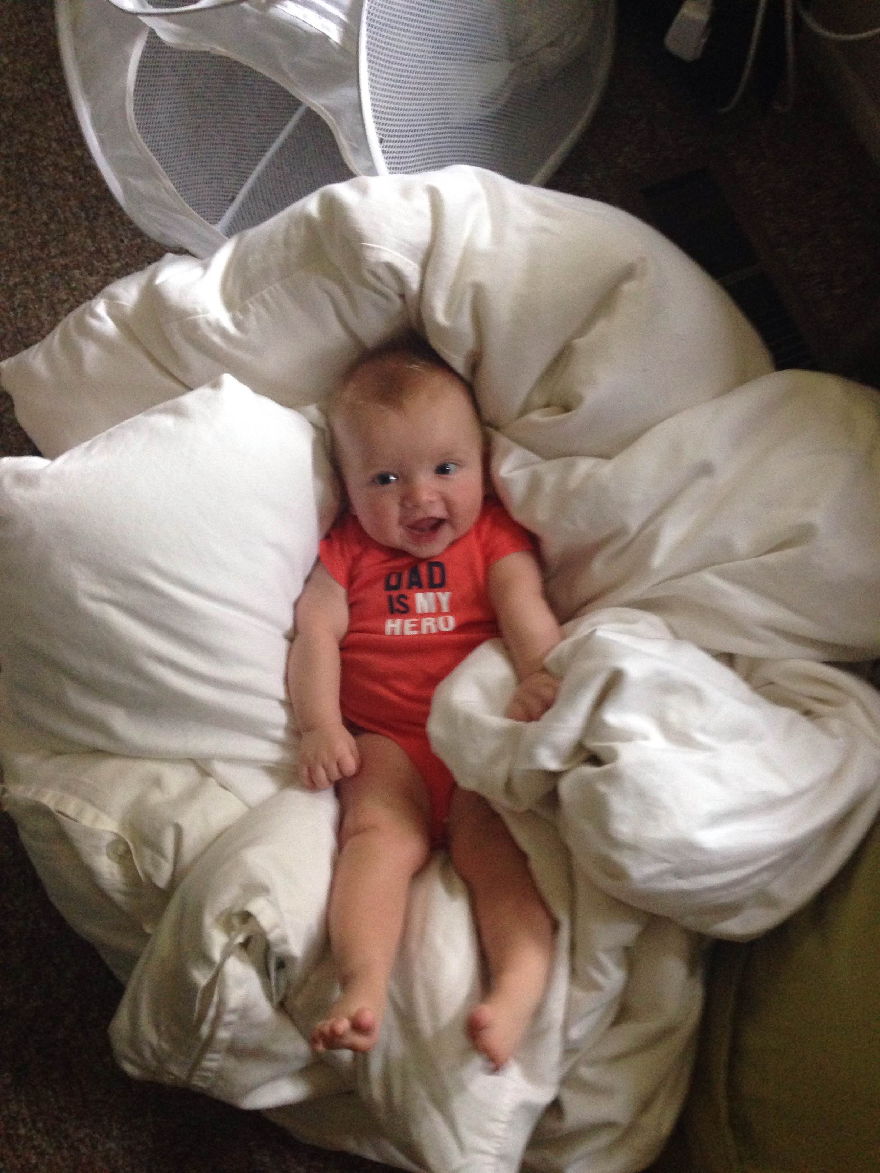

And Uncle T, I am sure you were just flying high this week when you realized you were predicted and looking pretty good to beat the Parental Powers and stop their winning streak.

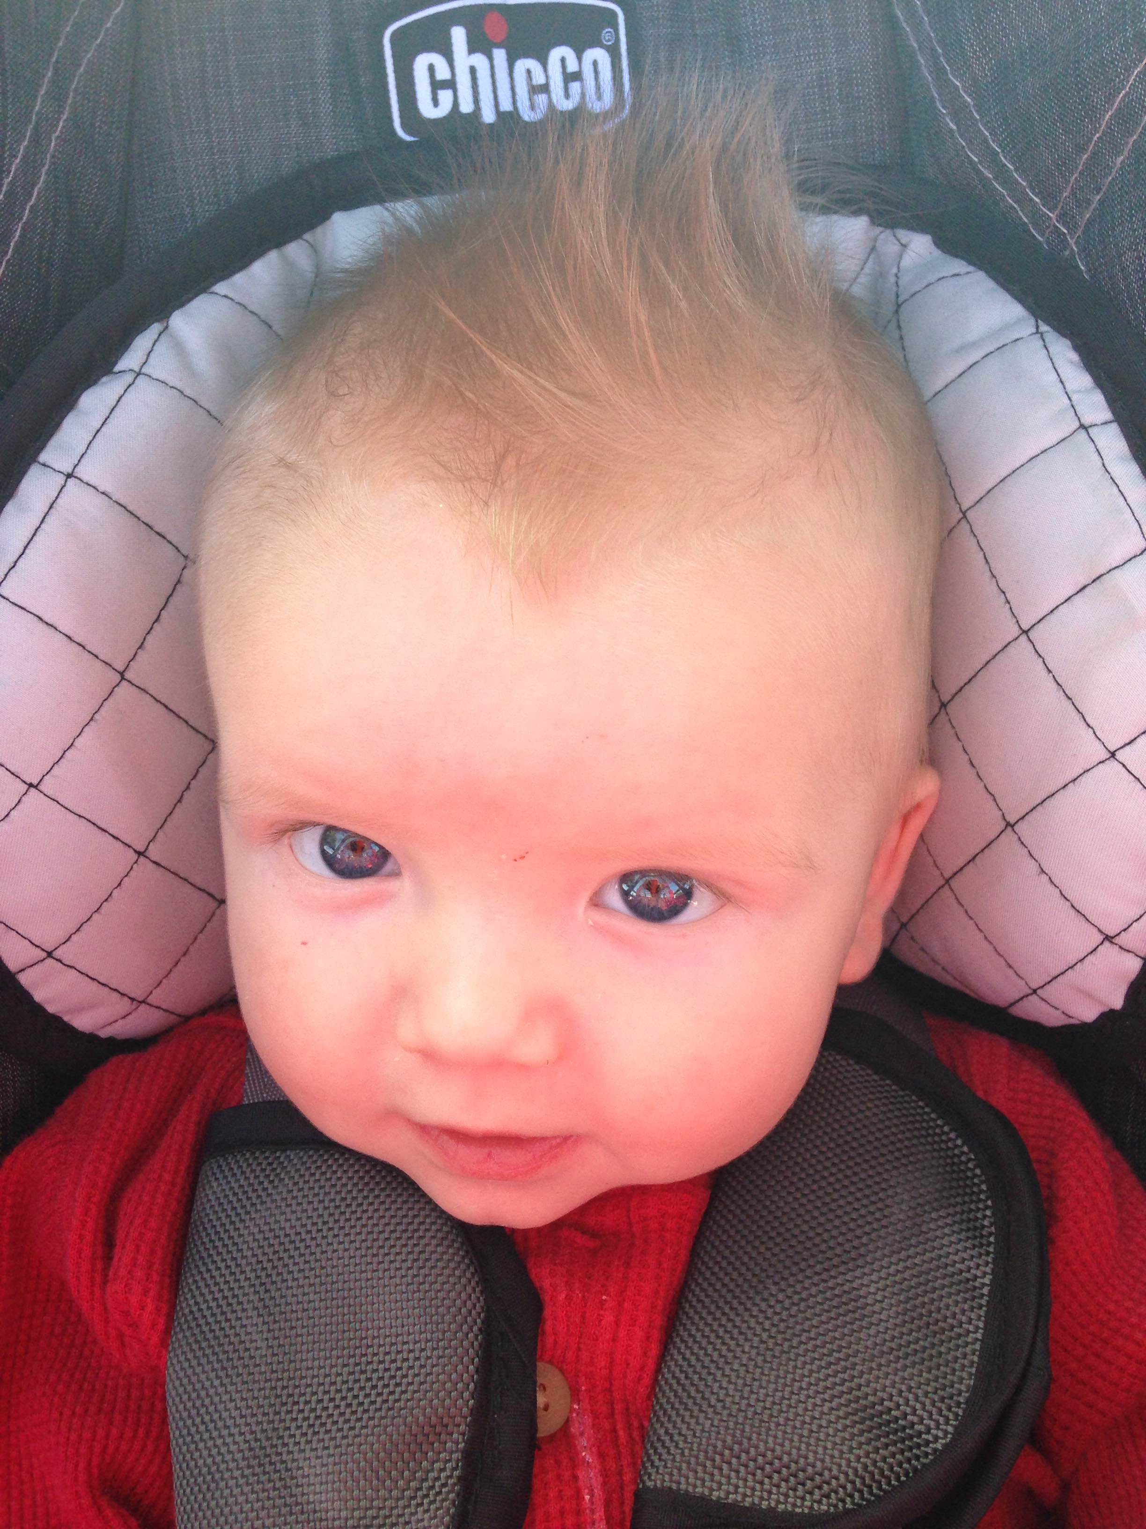

Man, I AM ON FIRE!!!!!!!!!!

Yet, Antonio brown was not on fire….. what a shame…….

As for mema and papa, I was thinking they might just have had too much going on to fully concentrate on deciding who to play this week. #baltimoreboldwasmaybetoobold #shouldhaveplayedflacco #ifeeloverwhelmed

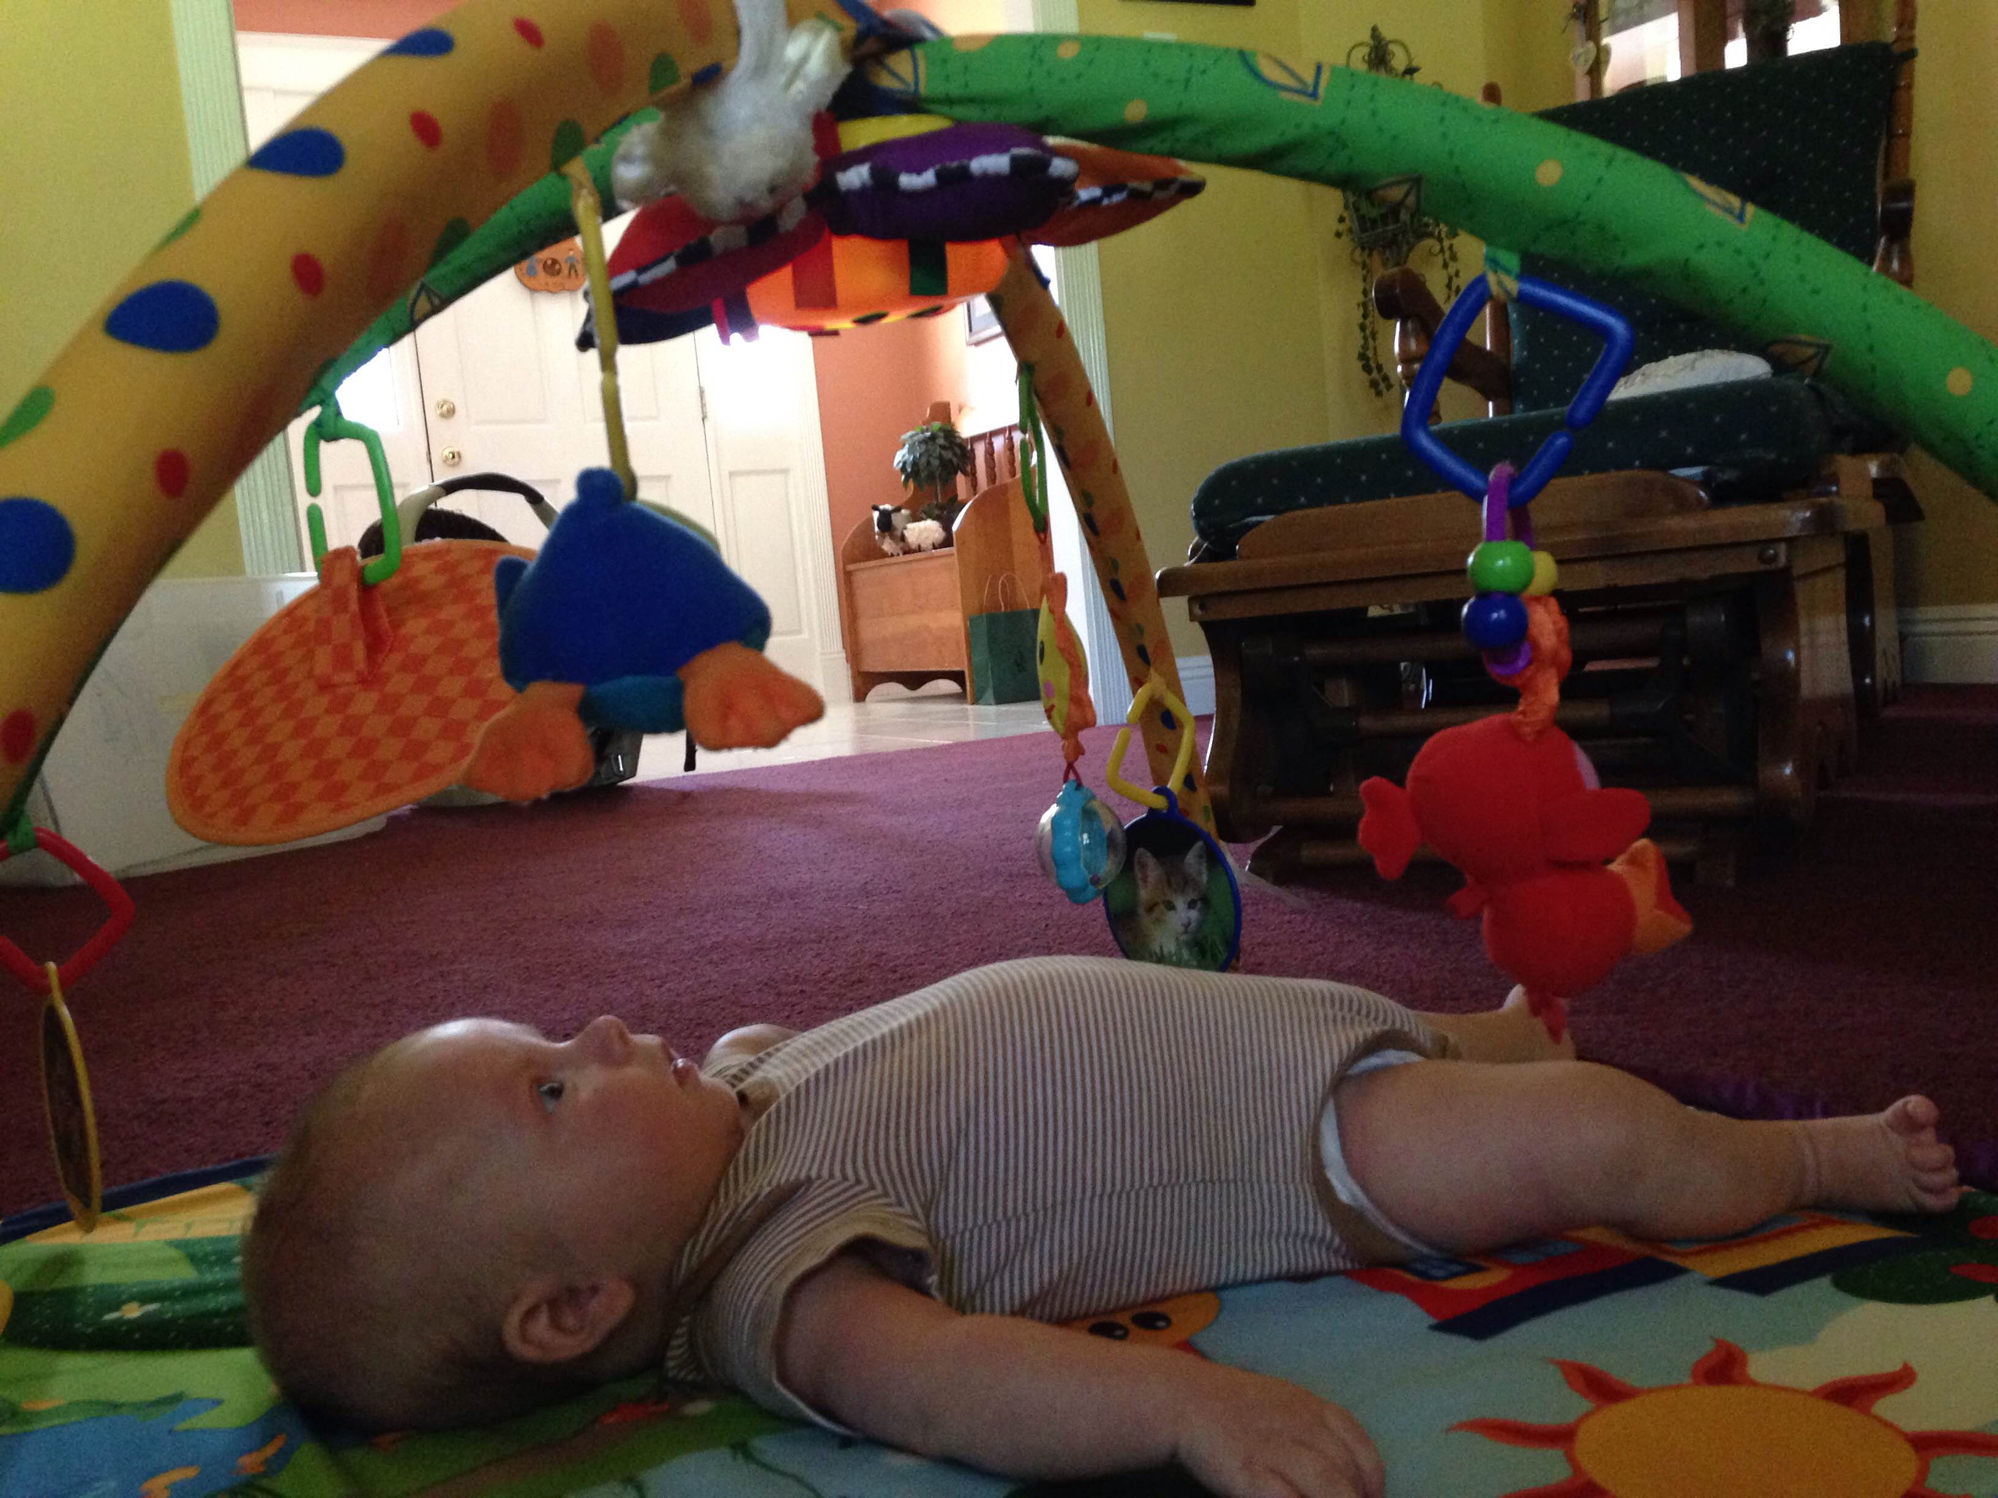

And yet, you pulled through once again. (If I am honest, I wrote most of this before Monday’s night’s game really thinking Tyler was going to pull through, and so I had to compromise my original comments that went with these pics…ha)

As to what Mommy felt this week,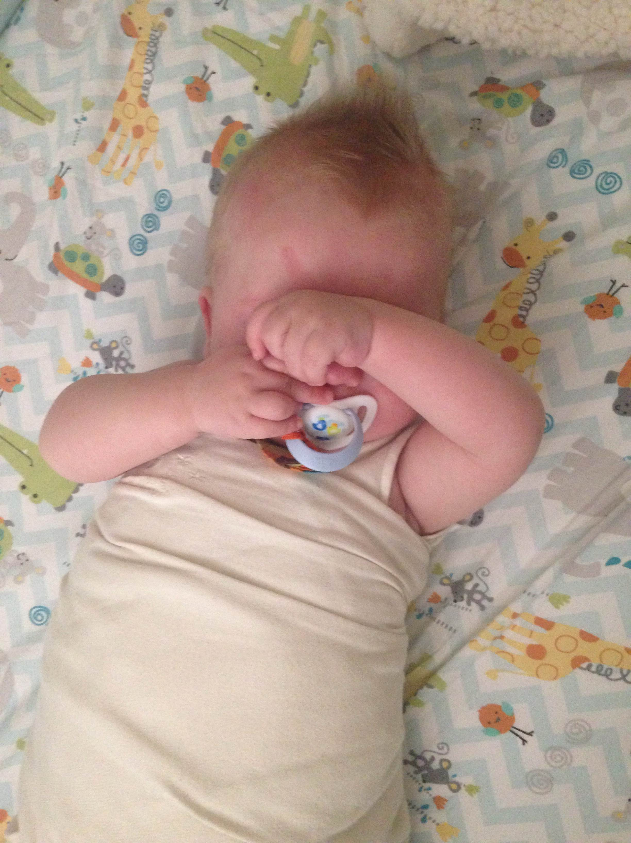

Lets just say she doesn’t want to talk about it……the one time the 49ers happen to do good is the one time she picks up the defense who were playing against them thinking they would get big points…..because the 49ers have been terrible……except for this week……

Not to mention Russel Wilson’s poor performance this week…..

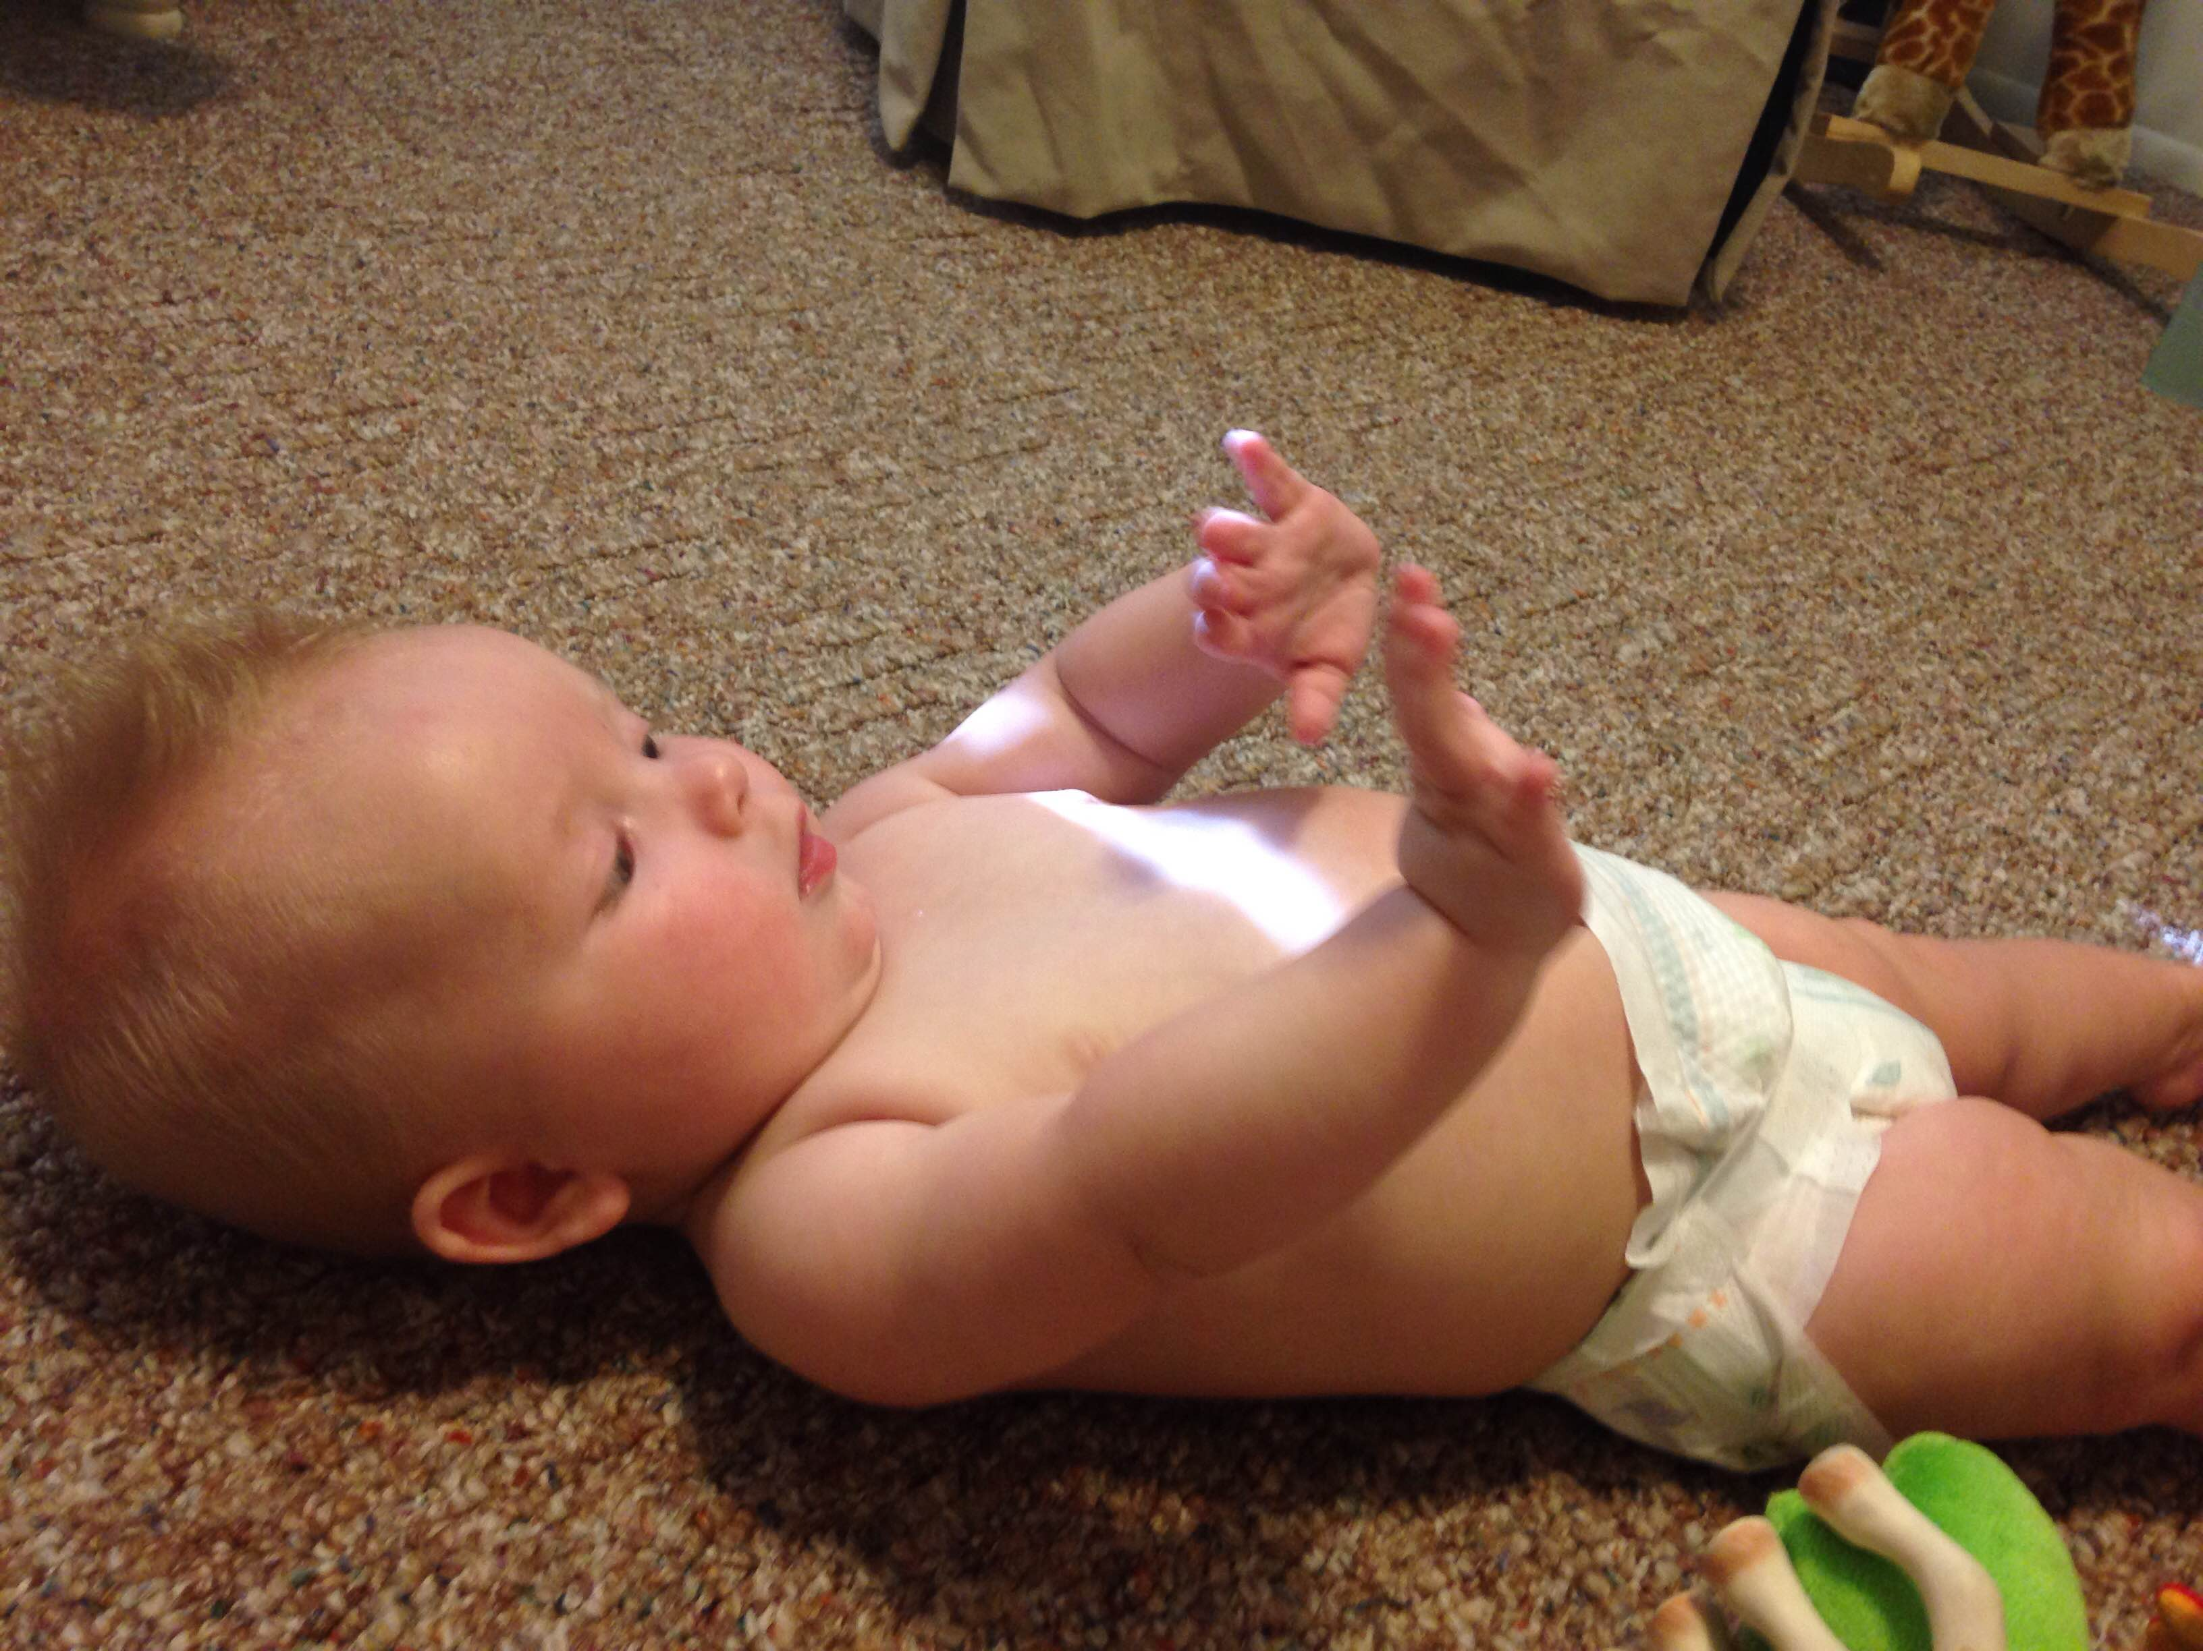

“Dude, I’m open, throw me the ball. ……Yup, still open, still waiting, still have perfect hand and field position….just waiting on you…..ok guess you want to just get sacked….again…..and again…..and again……

And last but certainly not least… there is daddy. And lets just say he was pretty happy with the way his team played….